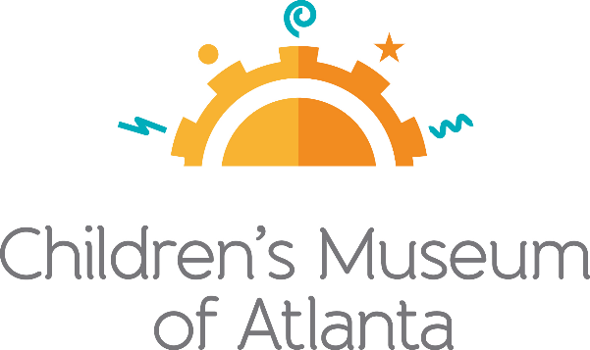

CONTACT
Jennifer Walker
BRAVE Public Relations
404.233.3993
jwalker@emailbrave.com

*MEDIA ADVISORY*
Children’s Museum of Atlanta introduces Tiny Teams, beginning Sept. 16
Four-week themed pod learning program offers a drop-off, play-based educational experience

ATLANTA (September 8, 2020) –Children’s Museum of Atlanta has lined up an all-new four-week program geared for Pre-K and Kindergarten students called Tiny Teams. Launching on Wednesday, Sept. 16, Tiny Teams is a small group drop-off experience that gives children a fun, play-based learning experience while affording parents some extra time during the work week. During each two-and-a-half-hour session, children will be placed in pods of five or less with an assigned play-facilitator leading activities, including story time, hands-on science and creative projects. Each week, the children will stay in the same group to limit interactions, and additional social distancing, handwashing and health protocols will be in place. Parents will also receive notifications with pictures, quotes and details about each session’s events.

WHAT/
WHEN: Tiny Teams
Drop-off, play-based educational sessions in pods of five or less

90-minute sessions available at 9 a.m. and 2 p.m. each Wednesday
Sept. 16: Friendship & All About Me
Sept. 23: Weather
Sept. 30: Animals!
Oct. 7: Storytelling

WHERE: Children’s Museum of Atlanta
275 Centennial Olympic Park Dr NW, Atlanta, GA 30313

HOW: Learn more and register by visiting childrensmuseumatlanta.org/tiny-teams

Cost is $150 per child for the full four-week program; $125 for Museum members

For more information or to support Children's Museum of Atlanta,
visit childrensmuseumatlanta.org or call 404.659.KIDS [5437]

